DATE: 17.01.2020
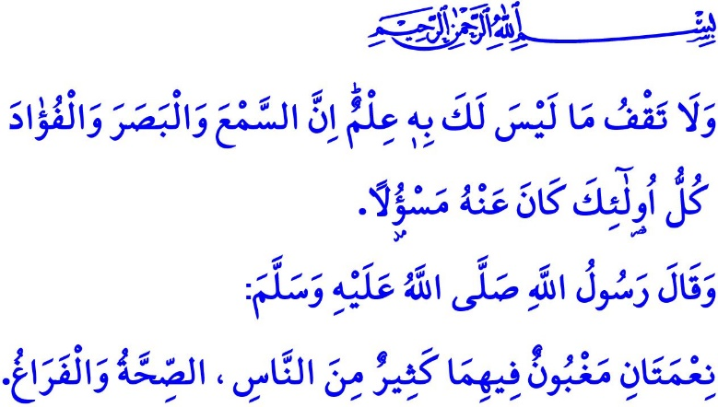
TECHNOLOGY ADDICTION AND SOCIAL MEDIA ETHICS
Honorable Muslims!
Islam primarily aims to ensure that the lives, properties, mental health, dignity, and faith of human, created to be the most honorable being on earth, are protected. It regards these five values inviolable. It does not approve in any manner these values being undermined for any reason. Binding all spheres of life, this fact is also applicable to using technology, and the Internet and social media.
Dear Believers!
What fits a Muslim is to use the technology properly as approved by the religion, ethics, and common sense. To consider the Internet as a purposeless, useless and uncontrolled medium means to violate the five fundamental values Islam wants protected. This is because the inconsiderate use of technology harms human life by exposing threat to human health and inflicts costly damage to property by causing financial loss. It erodes human dignity through unethical orientations and human faith through radical and perverse ideologies. It impairs the ability to think and comprehend, and challenges the mental faculties.
Dear Muslims!
People who produce technology using the reason and material given by Allah (swt) are accountable to use it in good cause. By using technology if they go after gambling instead of halal earning, extravagance instead of moderate spending, morally ill practices instead of honorably living, and violence instead of compassion, then greatly mistaken are they. It means they spread sedition by their own hands, and put their future in danger. Moreover, if they kill their time behind a television or computer screen, then they become accountable against themselves, their families, and Allah (swt). It is unfortunate that the number of families living under the same roof unaware of each other is increasing day by day. The technology, expected to buy time by speeding up the processes for human, has turned into the most deceiving trap for waste and loss of time today. Prophet Muhammad (saw), however, warned us as follows, “There are two blessings that many people lose: Health and free time.”
Dear Believers!
Occupying a great place in the lives of everyone, the Internet and social media should be prevented from turning into an area uncontrolled, unprincipled, and free of responsibility. What suits a Muslim is to always act responsibly observing the boundaries set by Allah (swt), and to uphold the truth and the right at all times. Let us not forget that just as in the offline life, it is haram to violate the rights and privacy of people on the social media as well. Any step in disrespect of privacy of people contradicts the divine commandment of Allah (swt), “Do not spy or backbite each other.” Just as it is a sin to tell a lie, defame people, and utter slanders at them in offline life, it is also a sin to do so online. Allah (swt) as the Lord of the Worlds watches us over online, too. He will bring us to account for all our words and acts online, too. In the verse I recited as I began the khutbah, Allah (swt) states, “Do not pursue that of which you have no knowledge. Indeed, the hearing, the sight and the heart - about all those one will be questioned.”
Dear Muslims!
Today it is not possible to live in a way completely isolated from technology. In fact, Islam does not want such a thing either. However, it is the primary responsibility of all of us to use the technology as aware of halal-haram, paying attention to protecting moral principles, without violating human rights and liberties. That way we might have more productive time and more meaningful efforts. We might render the world better and peaceful... As long as we use the technology in accordance with the limits and boundaries set by Allah (swt) as in all His blessings.

Bukhari, Riqaq, 1.
Hujurat, 49/12.
Isra, 17/36. General Directorate of Religious Services

